Azure Cloud

**Aim**: - To Administrate and manage azure monitoring in the azure portal.

# **Administrate and manage Azure monitoring in the Azure portal**

Azure Monitor helps you maximize the availability and performance of your applications and services. It delivers a comprehensive solution for collecting, analysing, and acting on telemetry from your cloud and on-premises environments. This information helps you understand how your applications are performing and proactively identify issues that affect them and the resources they depend on.

1. Create and configure an Azure​ Log Analytics workspace and Azure Automation-based solutions​
2. Review default monitoring settings of Azure virtual machines​
3. Configure Azure virtual machine diagnostic settings
4. Review Azure Monitor functionality​
5. Review Azure Log Analytics functionality​

Create and configure azure alert in azure monitor

Create an alert manually in virtual machine.

Virtual machine->Create alert->Create an alert rule->Create

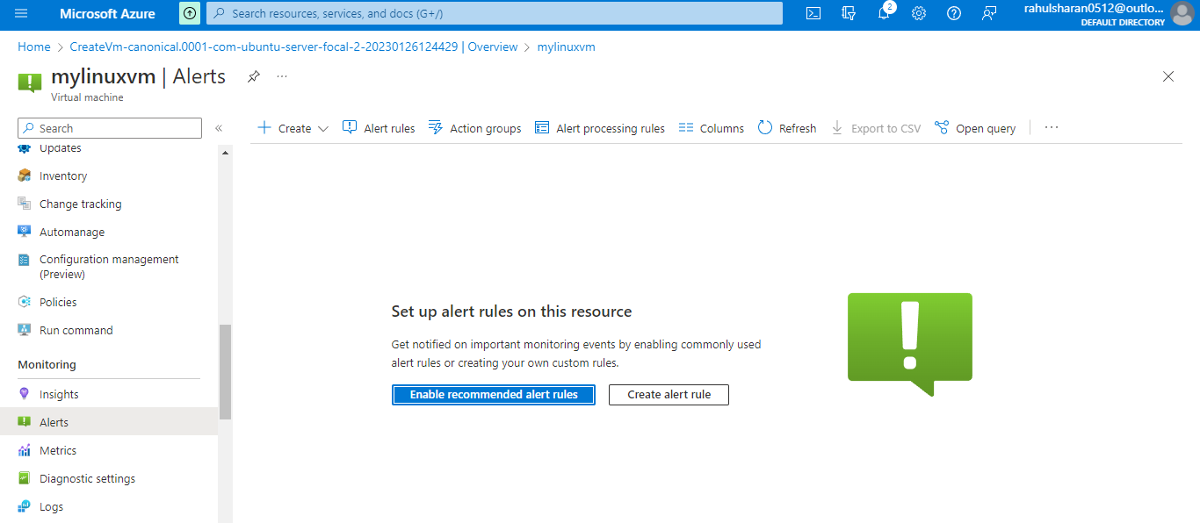

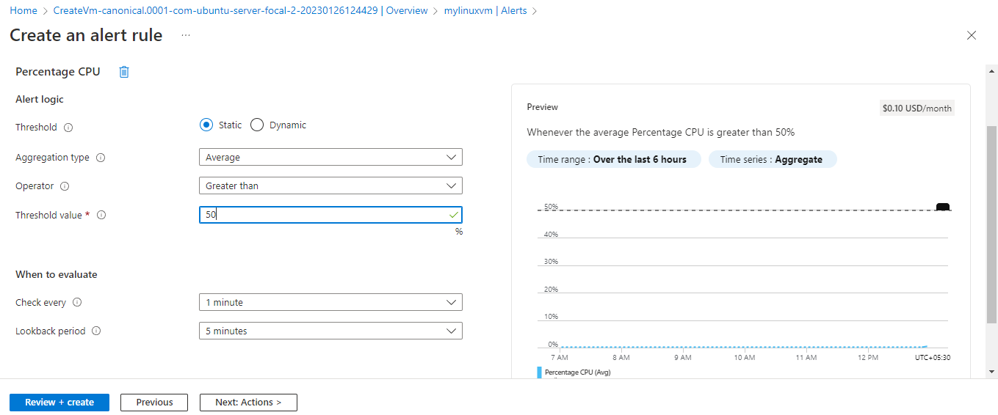

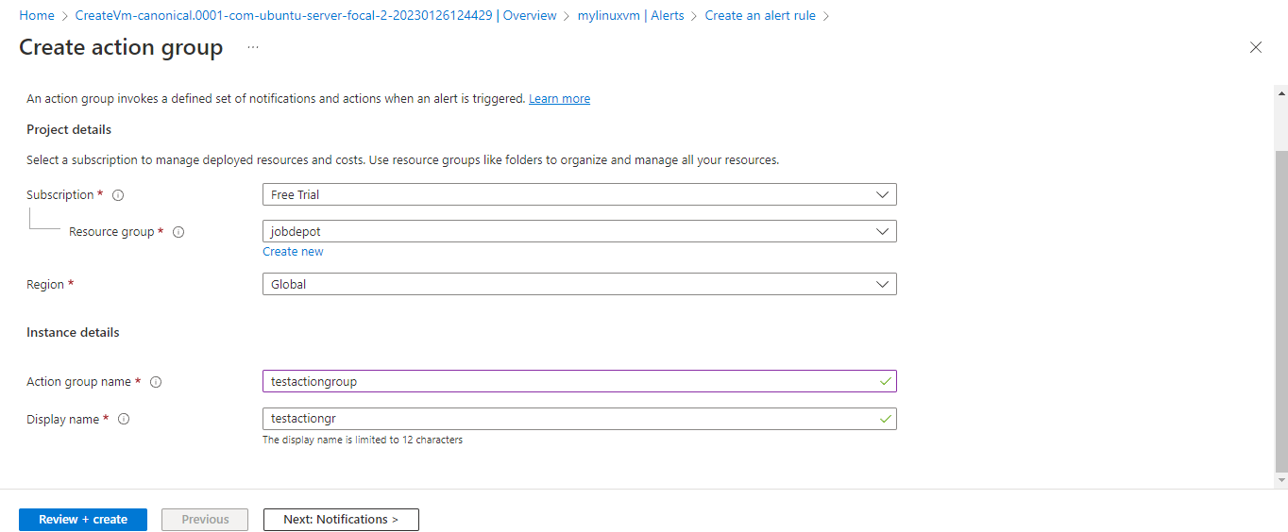

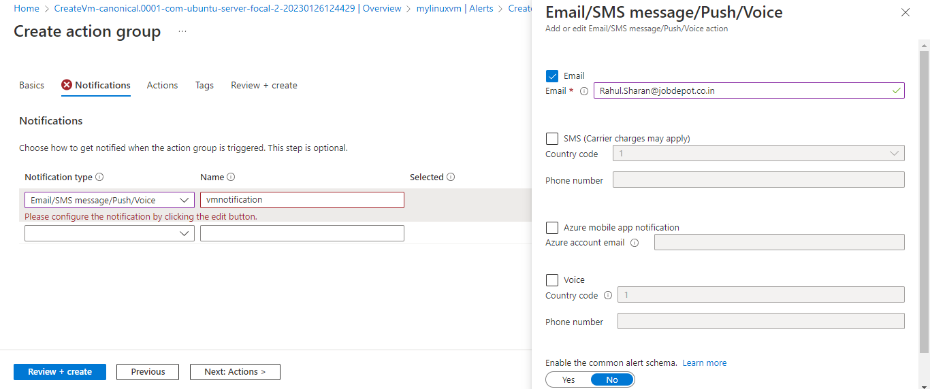

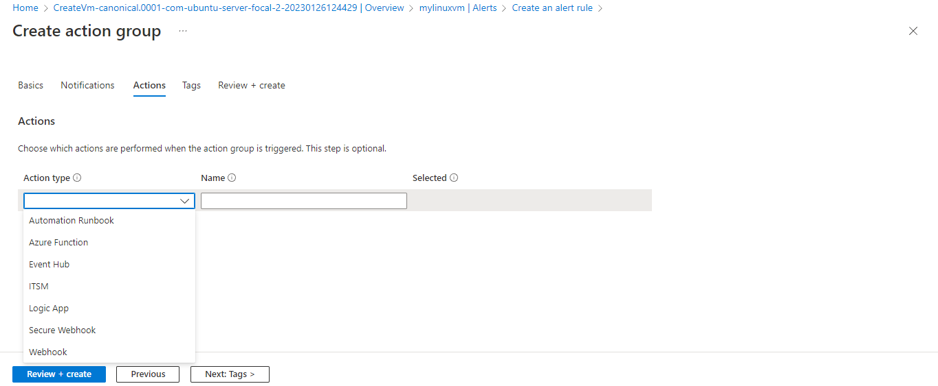

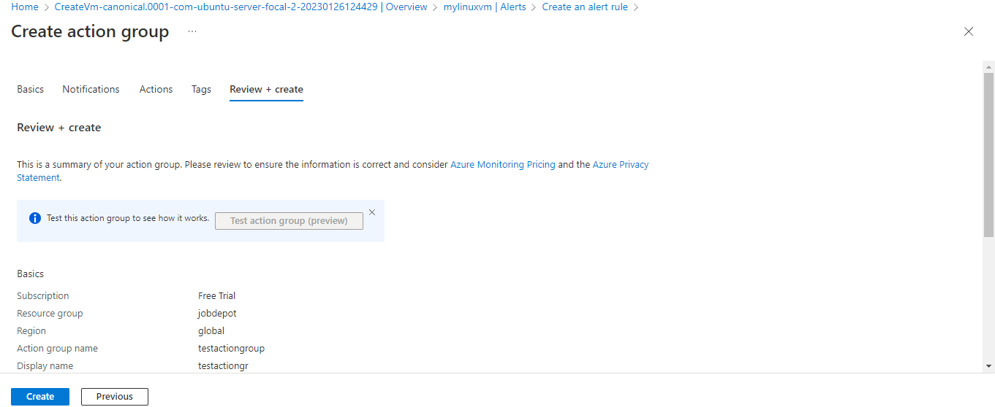

Create service health alert in virtual machine.

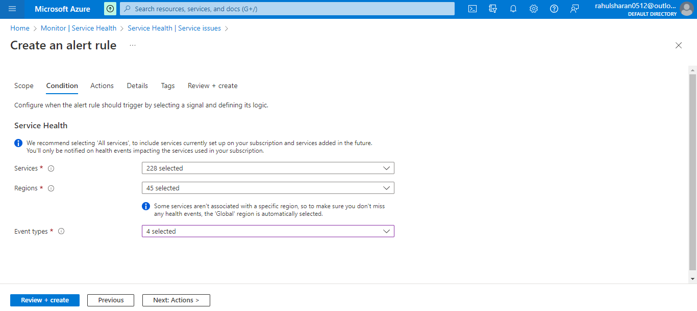

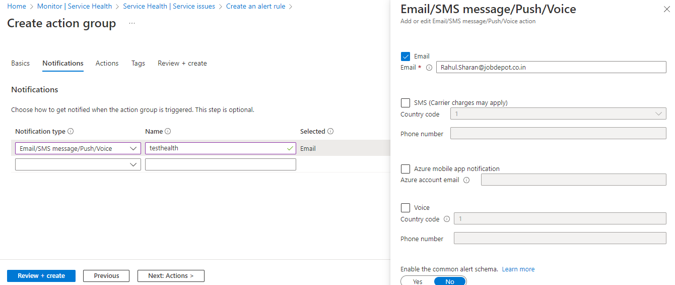

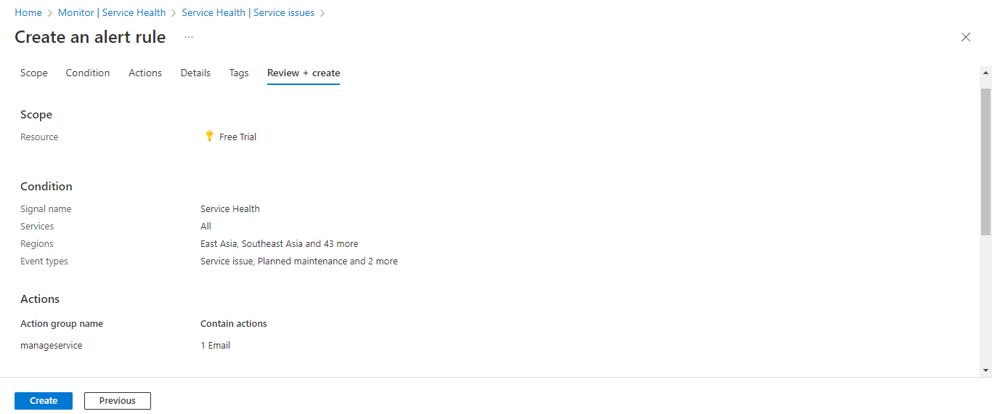

Successfully created health alert.

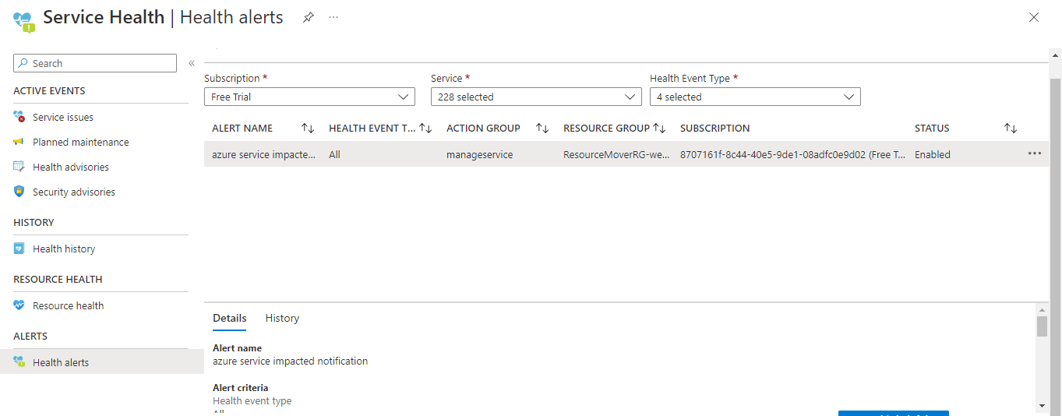

Create a virtual machine (monitorserver).

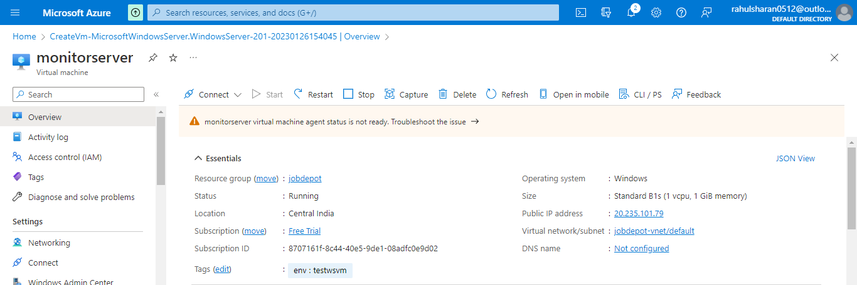

Enable guest-level monitoring in virtual machine (monitorserver)

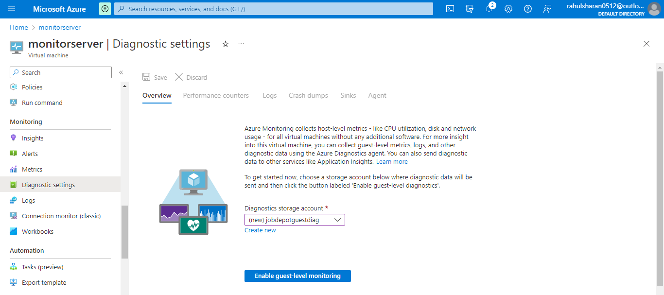

Create an alert manually in virtual machine (monitorserver).

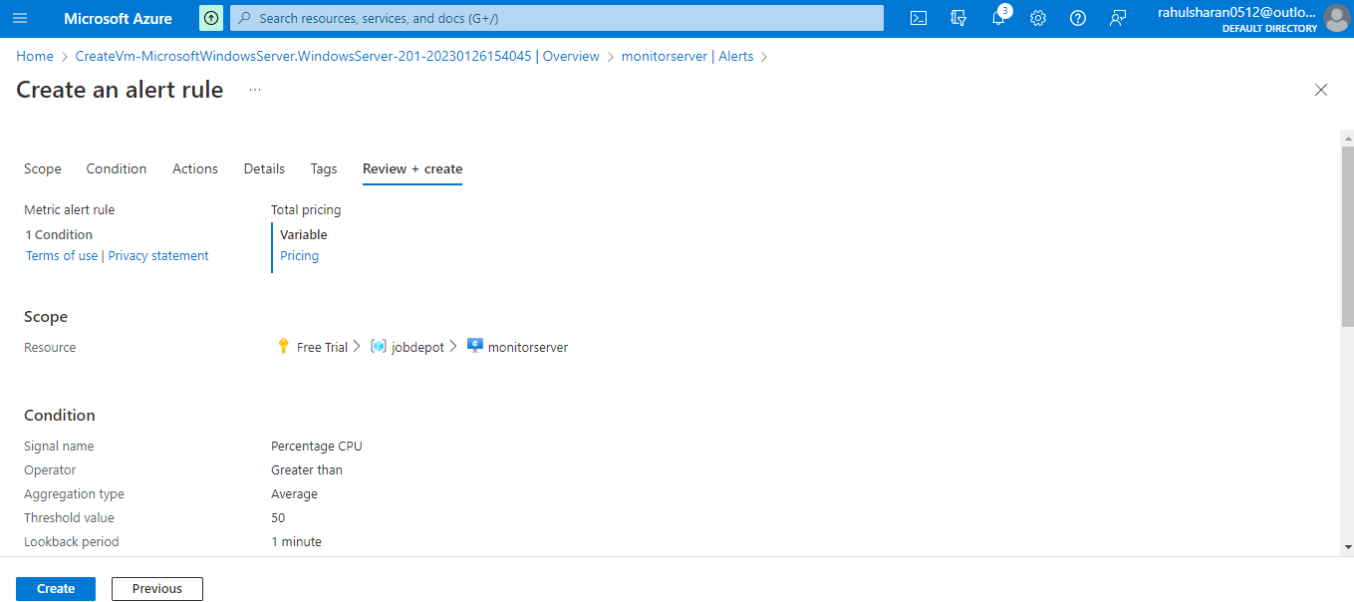

Successfully created alert rule in monitorserver.

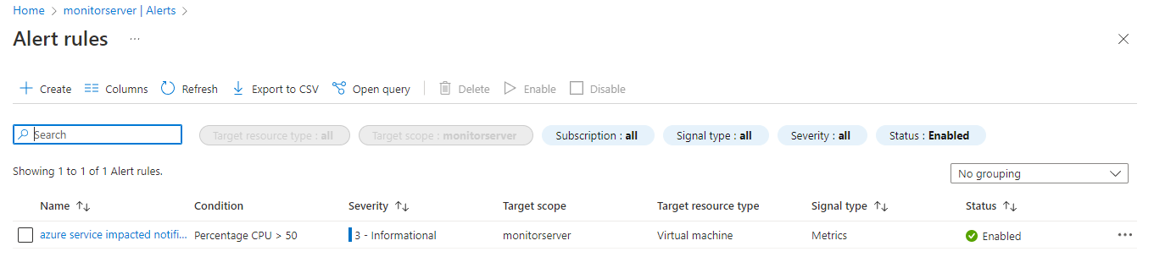

Installed heavy load software in monitorserver for checking the CPU and memory utilization.

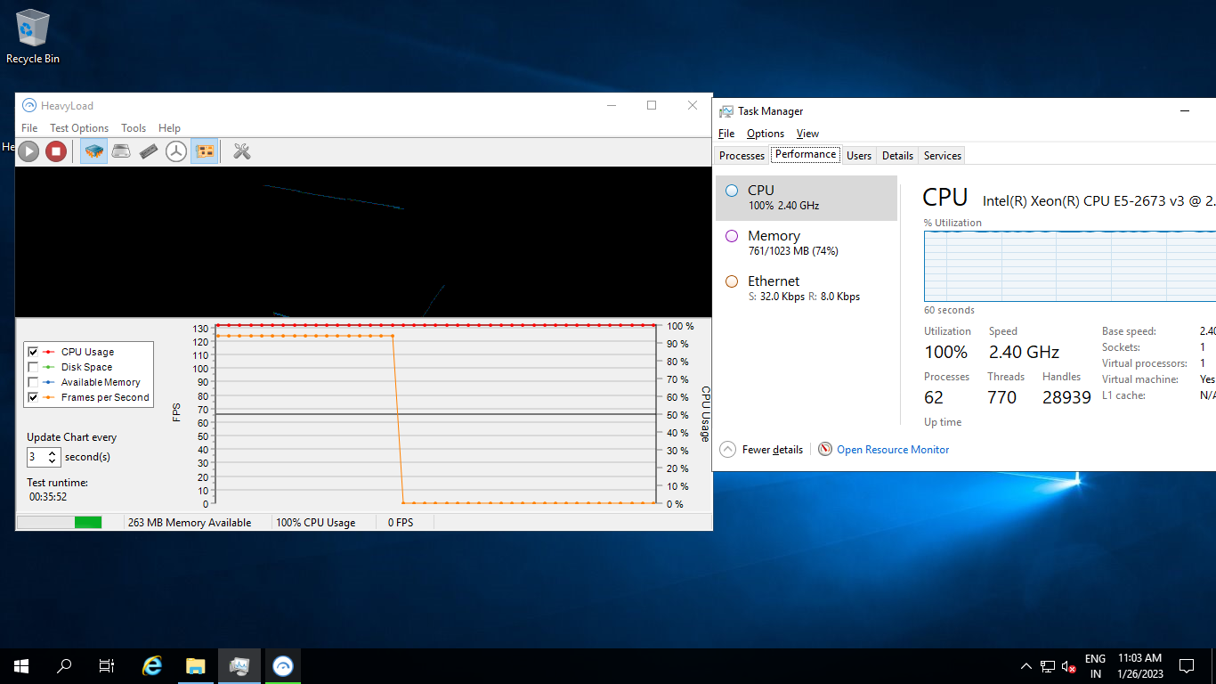

Azure service impacted notification alert in monitorserver.

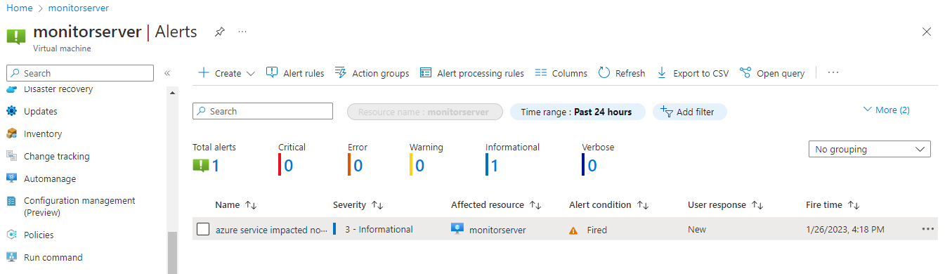

Azure service impacted notification alert in email_id.

